**JIRA**

**Understanding Jira for Users, Managers and Admins**

**Section 4: Jira for Administrators:**

1. **Creating a company-managed project:**

**1. Prerequisite: Global Administrator Access**

* To create a Company-managed project, you must be logged in with a **Global Jira Administrator** account.
* This is why the project (Customer Service Project) that was used in the previous "Manager" section has not been created yet; the video is demonstrating the setup process.

**2. Creating the Company-Managed Project**

* **Navigation:** Log in as the Global Administrator, go to **Projects**, and click the plus sign (**+**).
* **Selecting a Template:** Jira offers many templates, which are sorted by the Atlassian application they use.
  + **License Check:** The user is warned to only select templates for applications they are licensed to use (e.g., using a Service Management template without a license will start a free trial and incur a future cost).
  + **Template Choice:** The video uses the base **Scrum** template, noting that multiple Agile boards (Scrum and Kanban) can be added to a Company-managed project later.
* **Project Type:** The **Company-managed project** option, previously grayed out for a regular user, is now available and selected.
* **Project Details:**
  + **Name:** "Customer Service Project"
  + **Key:** The key is customized (e.g., "CS") to be shorter for work item keys (e.g., CS-1, CS-2).
* **Sharing Entities (Optional):** Jira allows sharing configuration entities (like schemes) from an existing project, which can speed up setup. This is skipped in the video to better demonstrate manual permission configuration later.
* **Skipping Post-Creation Wizards:** The video skips the wizards for **adding the team** and **connecting other Atlassian apps** (Confluence, Bitbucket) to focus on the next video's topic: setting up permissions manually.

**3. Next Step**

With the project created, the next video will focus entirely on configuring **permissions** to grant specific users (like Helen) administrative rights over this new Company-managed project.

===================================================================================

1. **Understanding permissions in Jira:**

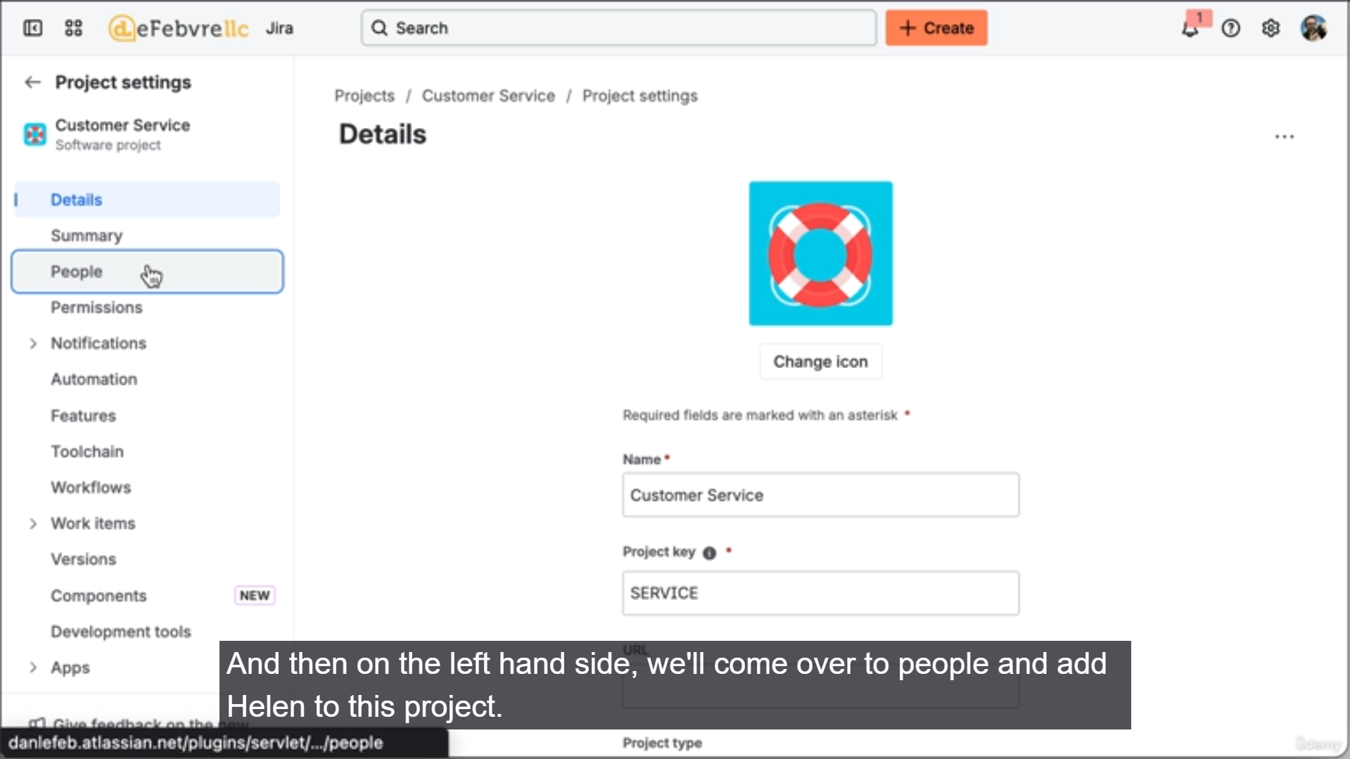

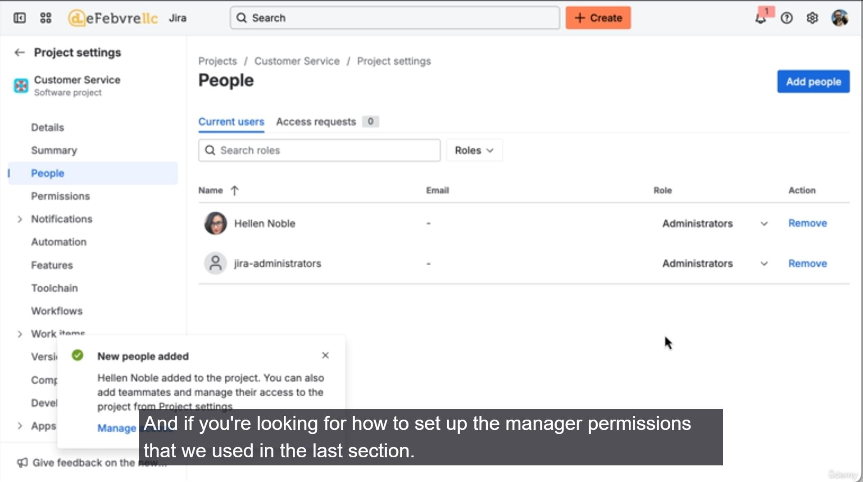

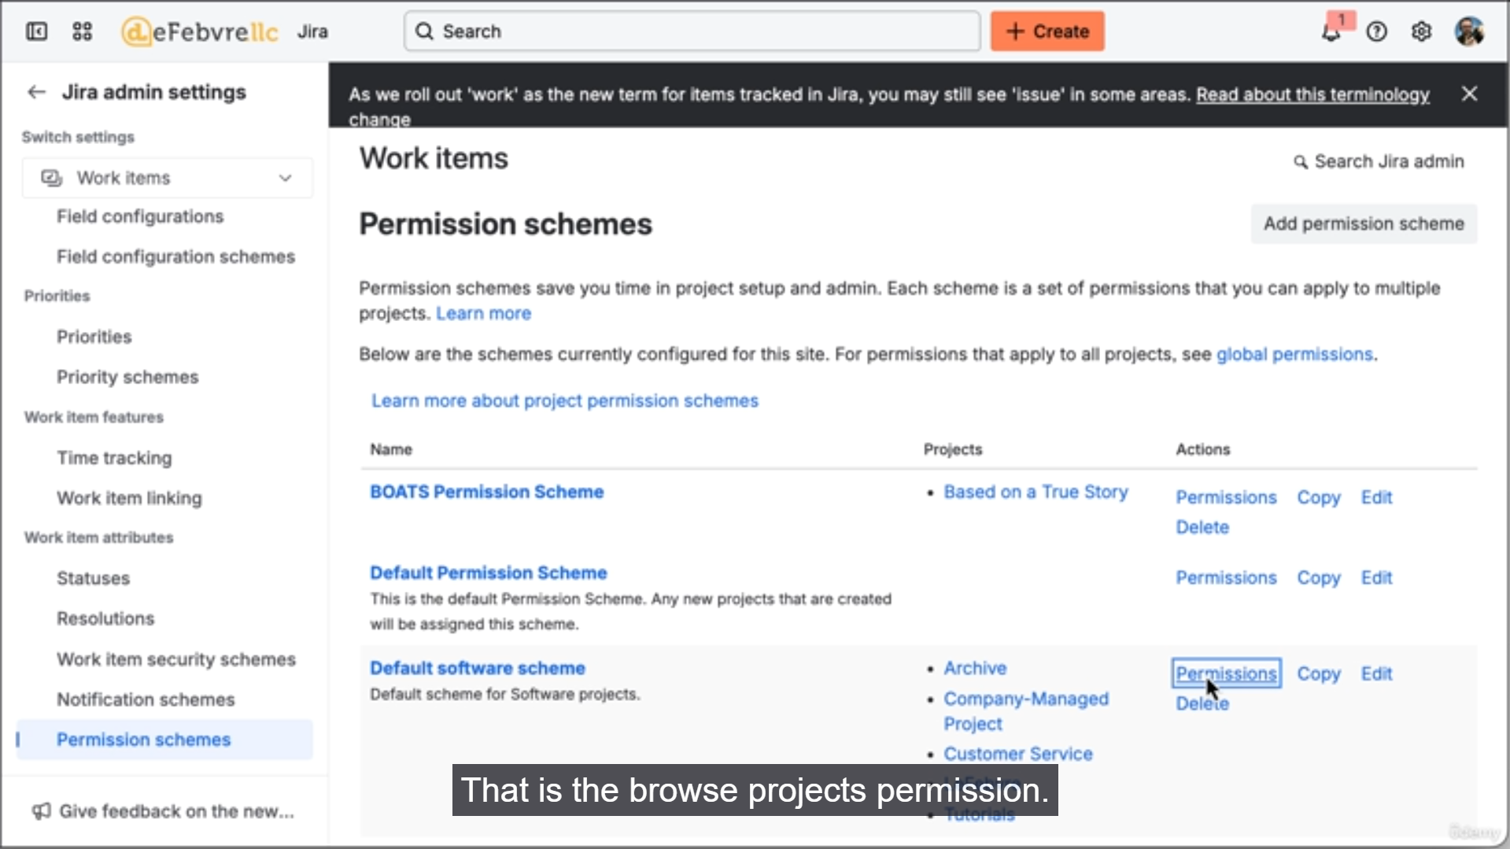

The video demonstrates how to set up a user as an administrator for a Company-managed project and then dives into the two higher layers of permission control in Jira: **Permission Schemes** and **Global Permissions**.

**1. Project-Level Permission (Bottom Layer)**

This is the fastest and most direct way to grant permissions for a single project.

* **Process:**
  1. Go to **Projects** (or "View all projects").
  2. Select the **Customer Service Project** and go to **Project Settings**.
  3. Navigate to **People**.
  4. Click **Add people** and add the user (**Helen**) with the **Administrator** role.
* **Result:** Helen now has all the project administrative permissions needed to perform actions seen in the "Jira for Manager" section.

**2. Permission Schemes (Middle Layer)**

Permission schemes allow you to control permissions across **multiple Company-managed projects** that share the same scheme.

* **Navigation:** Settings gear (**⚙️**) > **Work Items** > **Permission Schemes**.
* **Function:** Schemes define who can perform specific actions (like Browse, Create Issues, Manage Sprints) and apply those rules to all projects associated with that scheme.
* **Demonstration (Browse Projects):**
  + The user removes the **Browse Projects** permission for "Any logged-in user" from a scheme.
  + **Effect:** When Helen (the regular user) refreshes, all projects using that scheme disappear from her view. Helen can still see the Customer Service Project because she was explicitly added as an Administrator there.
  + **Fix:** The **Browse Projects** permission is restored, and all projects reappear for Helen.
* **Example (Manage Sprints):** You can grant the **Manage Sprints** permission (ability to create, edit, and complete sprints) to a specific **Group** (e.g., the Jira Administrators group) via the scheme, applying that rule to all linked projects.

**3. Global Permissions (Top Layer)**

Global permissions apply across the entire Jira instance, affecting all projects.

* **Function:** Controls overarching user rights, such as who can bulk-change items, administer the entire Jira application, or access certain sections.
* **Jira Administrators Group:** This is a default group created by Jira. Any time you see Jira asking about granting administrative permissions, it is generally adding that user to this global group.

**4. Introduction to Groups**

The discussion about permissions leads into the topic of **Groups**.

* Groups are a way to manage user permissions more efficiently (e.g., granting all members of the Jira Administrators group permission to manage sprints).
* The next video will detail how to create and manage custom groups.

===================================================================================

1. **How user management works in Jira:**

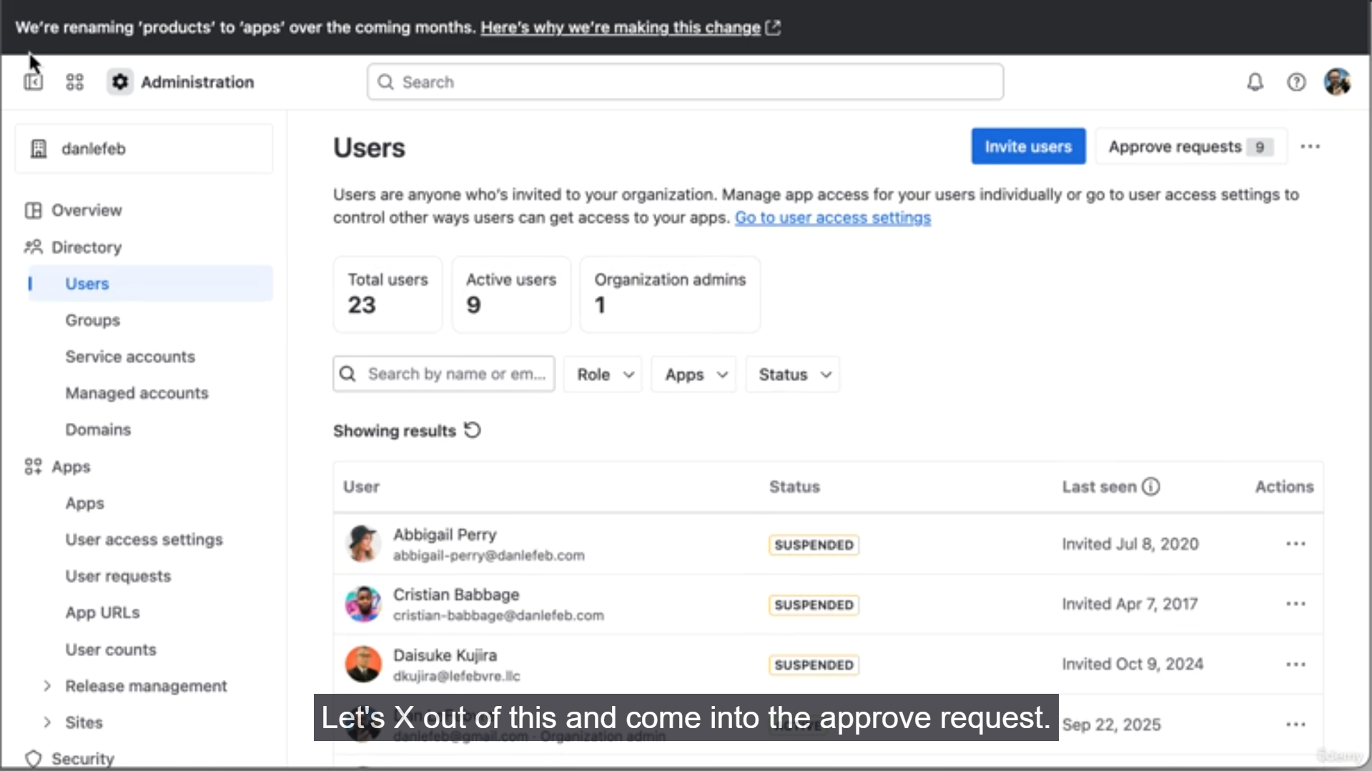

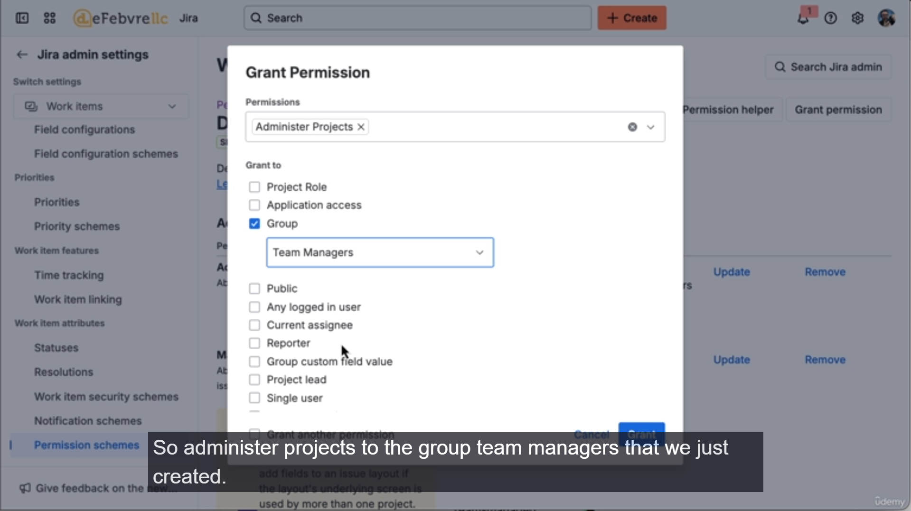

The video explains where user management lives in the Atlassian ecosystem, the concept of active versus inactive users, and demonstrates how to use **Groups** to manage project administrative permissions efficiently via **Permission Schemes**.

Here is a summary of the key points:

**1. User Management in Atlassian Administration**

* **Users Live Outside Jira:** User accounts are not managed within Jira itself. They reside in the global **Atlassian Administration** area, which you access via the settings gear (**⚙️**) > **User Management**.
* **Global License Model:** This centralized management is because user accounts apply across all Atlassian products (Jira, Confluence, etc.) that an organization might license.
* **Cost is Based on Active Users:** You can create any number of users, but you only pay for **active users** (those who currently have product access).
  + **Benefit:** If a user leaves the team, you revoke their access (making them inactive) instead of deleting their account. This preserves all their historical work and data within Jira without incurring a monthly fee.
* **Adding New Users:** You can invite new users by email and grant them roles (regular user or administrator) and app access (Jira, Confluence, etc.).
* **Managing Access Requests:** As a Jira administrator, you will manage access requests from new users in the **Approve Request** section of Atlassian Administration.

**2. Using Groups to Manage Permissions**

The video demonstrates the efficiency of using groups instead of managing individual user permissions across multiple projects.

* **Goal:** Grant Helen (and future managers) administrative rights over multiple projects.
* **Step 1: Create a Group:** In the Atlassian Admin area, create a new group (e.g., Team Managers) and add Helen to it.
* **Step 2: Remove Individual Permission:** The previously set individual Administrator role for Helen on the Customer Service Project is removed to prove the group-based access works.
  + **Result:** Helen loses the ability to see project settings on the project.
* **Step 3: Grant Permission to the Group via a Scheme:**
  1. Go to Jira's **Permission Schemes** (Settings > Work Items > Permission Schemes).
  2. Select the scheme used by the Customer Service Project (and other projects).
  3. **Grant Permission:** Select the **Administer Projects** permission.
  4. Set the permission to the newly created **Group: Team Managers**.
* **Final Result:**
  + Helen, as a member of the Team Managers group, instantly regains administrative access to the Customer Service Project.
  + Critically, Helen also gains administrative access to **any other project** that uses the same permission scheme.
  + This setup allows the administrator to add any new manager to the Team Managers group to instantly provision their access across multiple projects.

**3. Next Steps**

The next video will provide an overview of other settings that can be customized in Company-managed projects.

===================================================================================

1. **Overview of the company managed project settings**

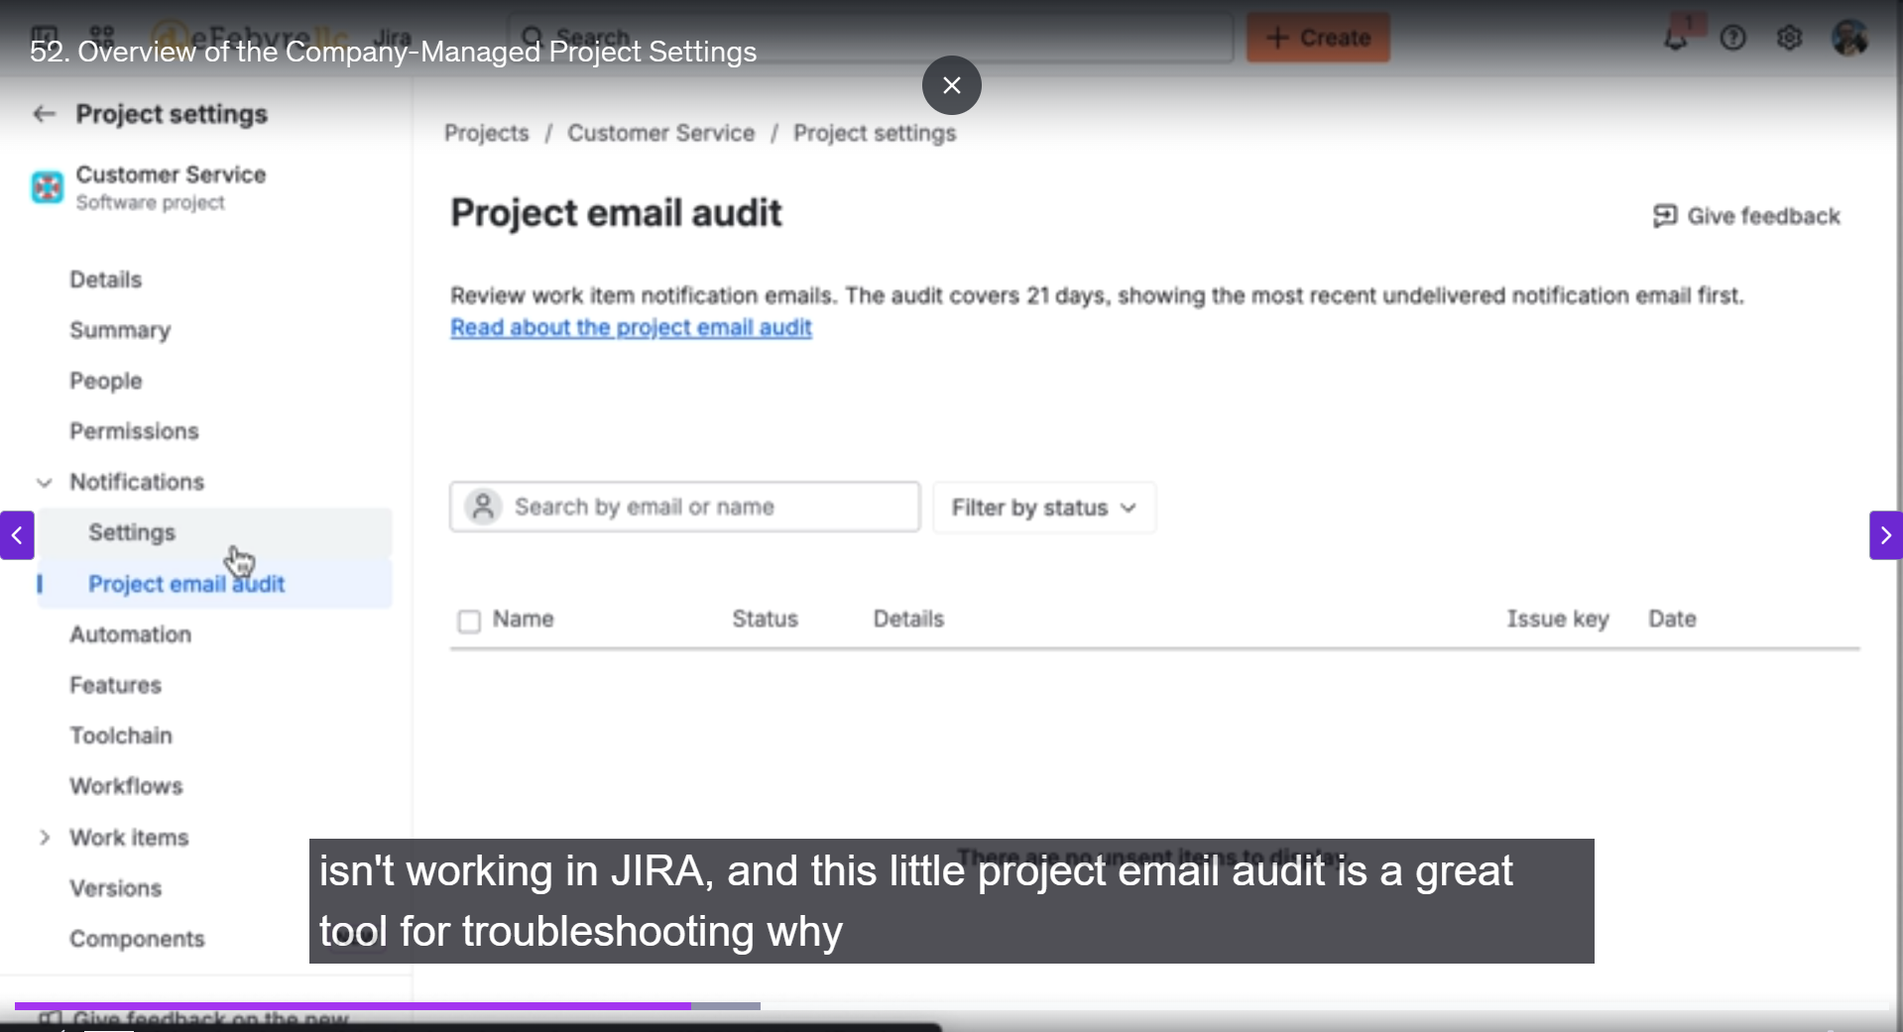

The video provides a high-level overview of the numerous settings available in a Company-managed project in Jira, emphasizing that these projects offer deep customization and use the concept of **schemes** to share configurations.

Here is an overview of the key settings covered:

**1. Project Details and Summary**

* **Details:** Allows changing basic project attributes like the name and the project key.
* **Summary:** This is a quick reference page that shows all the configuration schemes currently connected to the project (e.g., Permission Scheme, Notification Scheme, Workflow Scheme, Screen Scheme). This is the fastest way to see the underlying architecture of the project.

**2. User & Security Settings**

* **People:** Shows which users and groups have access. By default, the **Jira Administrators** group is added with Administrator permissions, which is how global admins gain project access. This can be customized.
* **Permissions:** Displays the active **Permission Scheme** for the project. This scheme controls all user actions (who can browse, create, delete, etc.).
* **Work Item Security (Issue Security):** A form of permission control that limits which users or groups can **view** specific work items within the project.

**3. Communication & Auditing**

* **Notifications:** Uses a **Notification Scheme** to define when and to whom notifications are sent (e.g., when an item is created, all watchers, the assignee, and the reporter get a notification).
* **Project Email Audit:** A crucial troubleshooting tool. If a user claims they didn't receive a notification, this tool verifies if Jira successfully sent the email. If the email is not listed here, it means Jira failed; if it *is* listed, the issue is likely on the user's email client side.

**4. Integration and Automation**

* **Automation:** Allows creating automated rules (similar to IFTTT or Zapier) directly within Jira, based on triggers and actions.
* **Tool Chain / Development Tools:** Used to connect the Jira project with other external tools and repositories, such as Git providers (GitHub, GitLab, Bitbucket) and other Atlassian apps (Confluence).
* **App Integration:** Allows integration with communication tools like Microsoft Teams and Slack.

**5. Work Item Structure and Display**

* **Features:** Allows turning features (like the Timeline or Reports) on or off. It is recommended to turn off unused features to clean up the user interface.
* **Workflows:** Controls the statuses and transitions that work items in the project can move through. (Will be covered in a separate video).
* **Work Types (Issue Types):** Lists all the different types of work items (e.g., Epic, Story, Task) available in the project.
* **Layout / Screens:** Controls how the fields are displayed and organized when viewing or editing a work item. (Will be covered in a separate video).
* **Issue Collectors (Collectors):** Allows setting up a form that can be embedded on a website, enabling external users to automatically create work items in Jira.

**6. Organization and Tracking**

* **Versions:** Used to track software releases or product versions (e.g., 1.0, 2.0) and link work items to those versions.
* **Components:** A way to organize work items within a project into functional areas (e.g., "Login Functionality," "Checkout System"). (Will be covered in a separate video).

The video concludes by stating that the next topic will delve deeper into the concept of **Schemes**, which is central to configuring Company-managed projects.

===================================================================================

1. **Understanding the concepts of schemes:**

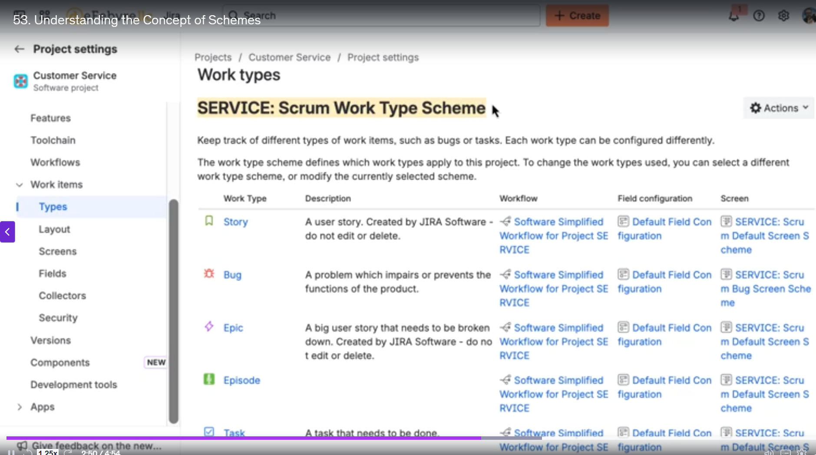

The video focuses on clarifying the concept of **schemes** in Jira, which are fundamental to configuring **Company-managed projects**. Schemes allow for the shared configuration of features across multiple projects.

Here is a recap of the main points regarding schemes:

**1. What are Schemes?**

* **Definition:** Schemes are a mechanism in Jira's administration interface that connect specific features or configurations (like permissions, workflows, or work item types) to one or more **Company-managed projects**.
* **The Rule:** A project can only have **one scheme per feature**. For example, a project can only have one Permission Scheme and one Workflow Scheme.
* **Complexity:** Since there are many different features that use schemes (Permission, Workflow, Notification, Work Type, Screen, etc.), a single project can have many schemes connected to it, each controlling a different aspect of the project's behavior.
* **Benefit (Sharing):** The power of schemes is that the same scheme can be applied to multiple projects. If you edit the scheme, the change is instantly reflected across all projects using that scheme.

**2. Demonstration: Work Type Schemes**

The video uses the Work Type Scheme (formerly "Issue Type Scheme") to demonstrate the impact of schemes.

* **Feature Control:** The Work Type Scheme controls which **work types** (Story, Bug, Epic, Task, etc.) are available when creating a new work item in a project.
* **Editing the Scheme:**
  1. The user first views the current Work Type Scheme for the Customer Service project, which includes standard types.
  2. They **edit the scheme** and add a custom work type (e.g., "Episode").
  3. **Result:** When creating a new work item in that project, the "Episode" type is now available.
* **Changing the Scheme:**
  1. The user demonstrates how to switch the Customer Service project from its current Work Type Scheme to a **different, pre-existing scheme** that is already used by other projects.
  2. **Result (Project Level):** The available work types in the Customer Service project instantly change to reflect the work types defined in the new scheme.
  3. **Result (Shared Impact):** If the user then edits this newly applied scheme, the change will affect the Customer Service project *and* all other projects that share that same scheme.

**3. Next Steps**

The next video will continue the topic of work item structure by teaching how to create **custom work types** in Jira. The video mentions that the next topic will cover creating custom work types. Based on the demonstrated concepts of schemes, this will involve two main administrative steps, which are summarized below.

The process of creating and using a custom work type in a Company-managed project typically involves:

**1. Creating the Custom Work Type (Global Step)**

Custom work types are created at the global Jira Administrator level so they can be used across the entire Jira instance.

* **Navigation:** You would navigate to the Jira Administration settings (Settings gear **⚙️**) > **Work Items** > **Work Types**.
* **Creation:** An administrator creates the new work type (e.g., "Episode," "Research," or "Technical Debt") by giving it a name, description, and choosing an icon. They also specify if it is a **Standard** work type (like a Story or Task) or a **Sub-task** work type.

**2. Adding the Custom Work Type to a Scheme (Project-Specific Step)**

Once created, the new work type must be added to a **Work Type Scheme** to become visible in any project.

* **Navigation:** The administrator would go to **Work Type Schemes** (Settings gear **⚙️**) > **Work Items** > **Work Type Schemes**.
* **Configuration:** The administrator would edit the specific Work Type Scheme that is associated with the target project (or projects).
* **Association:** The newly created custom work type is then added to the scheme's list of available work types.
* **Result:** All projects using that modified Work Type Scheme will immediately be able to create new work items using the custom type.

This two-step approach aligns with the schemes concept: the core feature (the work type) is created once globally, and its availability is controlled by the project-configurable scheme.

===================================================================================

1. **Creating custom work types:**

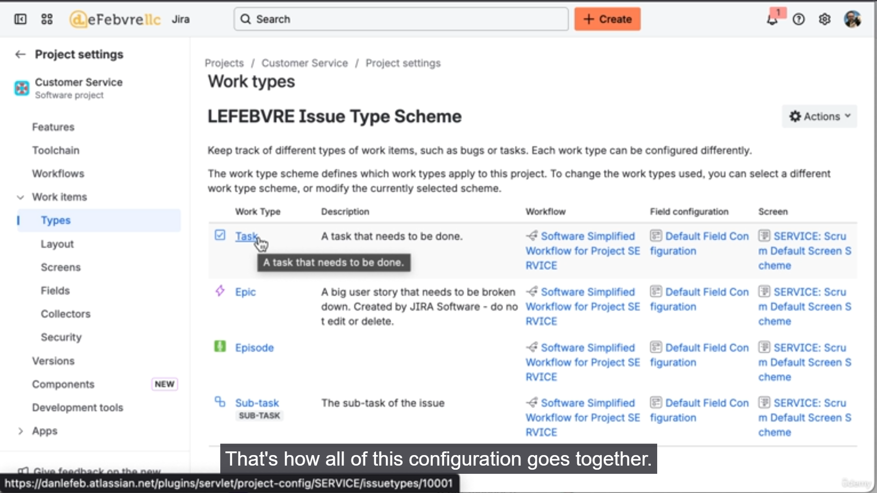

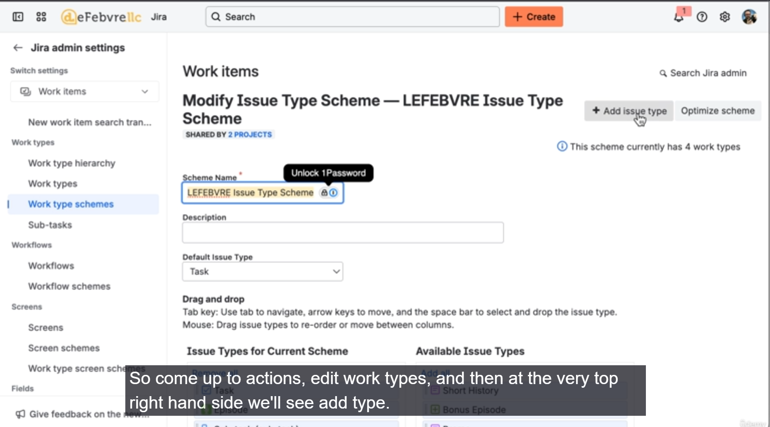

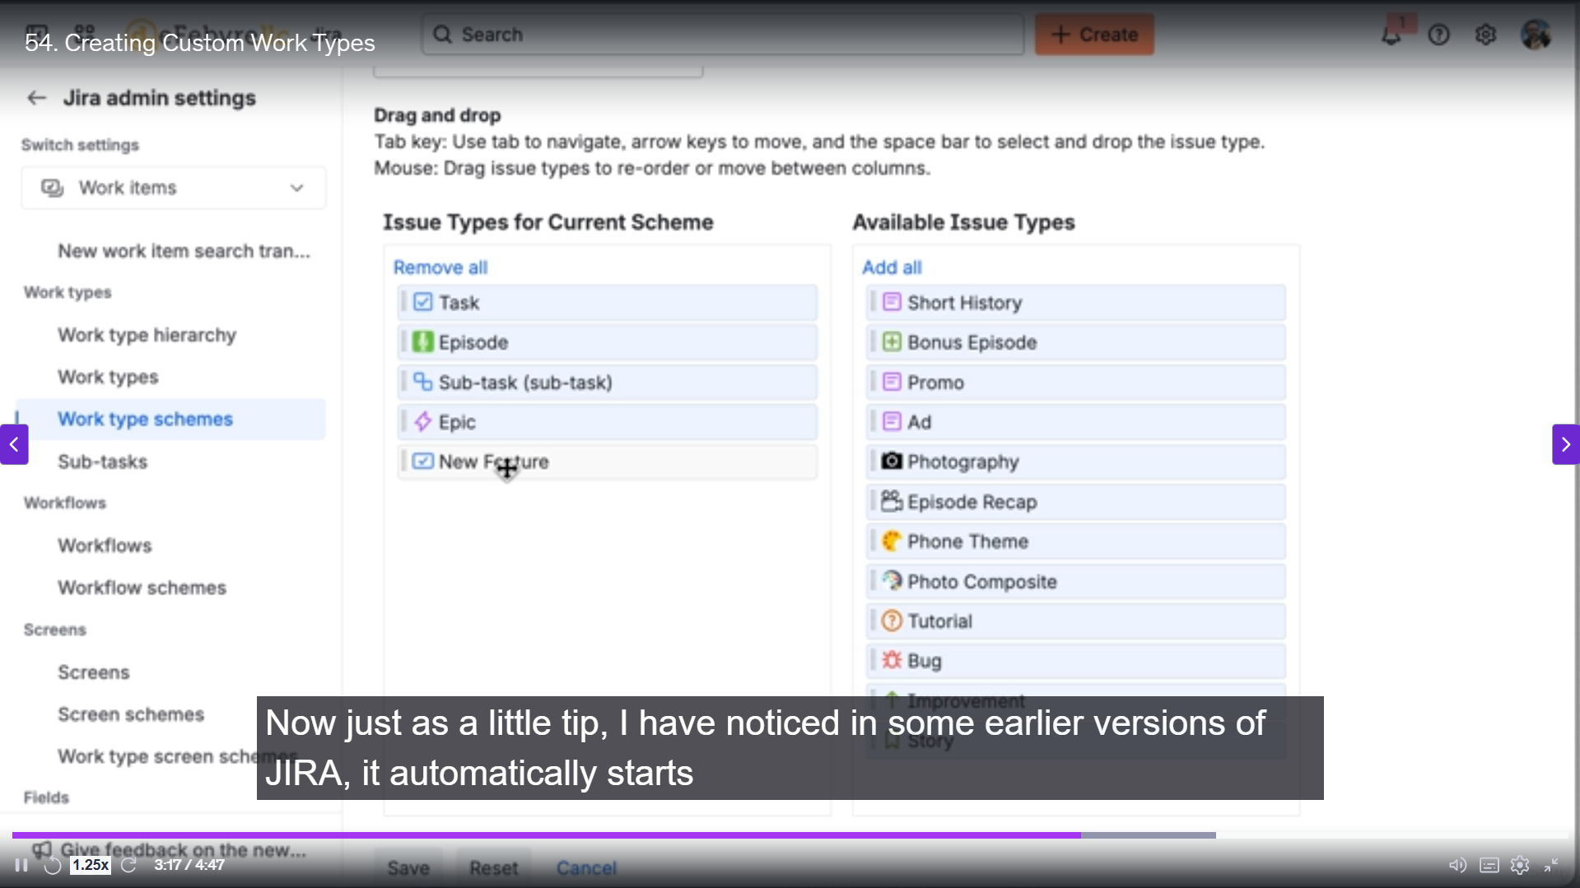

That's right! You've successfully created the new **"New Feature"** work type and updated its icon.

The next logical step, as you mentioned, is to **customize the fields** that appear on this new work type when you create, view, or edit it.

In Jira, the fields that are displayed for a work type are controlled by a combination of:

1. **Field Configurations:** These control the behavior of fields (e.g., whether a field is required, hidden, or has a different description) across all work types that use a specific configuration.
2. **Field Configuration Schemes:** This scheme maps different Field Configurations to different **Work Types** within a project.
3. **Screens:** These determine *which* fields are visible when a work item is **created**, **edited**, or **viewed**, and in what order they appear.
4. **Work Type Screen Schemes (or Issue Type Screen Schemes):** This scheme maps different **Screens** to specific **Work Types** for the *Create*, *Edit*, and *View* operations.

Since your new "New Feature" work type is currently using the project's default screen and field configuration, you'll likely need to:

1. **Create a new Screen** (or modify an existing, unshared one) that has the desired fields for your "New Feature" work type.
2. **Associate this new Screen** with the "New Feature" work type using the **Work Type Screen Scheme**. This will ensure that when you create, edit, or view a "New Feature" item, you see the customized set of fields.
3. Optionally, **create a new Field Configuration** to set specific field behaviors (like making a field required) just for the "New Feature" work type, and map it via the **Field Configuration Scheme**.

===================================================================================

1. **Creating and adding custom fields to work:**

You successfully accomplished the following key administrative tasks:

1. **Created a Custom Field:** You created a new **Single Choice Select List** custom field called **"Feature Location"** to ensure standardized data entry and better reporting, avoiding issues common with simple text fields.
2. **Added the Field to a Default Screen:** Initially, you added the field to the project's default "Service Scrum Default Issue Screen."
3. **Made the Field Required (and Fixed the Scope):**
   * You used the **Field Configuration** to make "Feature Location" a required field.
   * You correctly identified that this change made the field required on *all* work types, which was an issue.
4. **Used Schemes to Isolate the Customization:** This was the most advanced part, and you handled the hierarchy perfectly:
   * You duplicated the existing **Screen Scheme** to create a custom one (Customer Service New Feature Work Type Screen Scheme).
   * You duplicated the existing **Screen** (Service Scrum Default Issue Screen) to create a custom one (Customer Service New Feature Work Type Screen).
   * You updated the **Work Type Screen Scheme** to map the **"New Feature"** work type to your new custom **Screen Scheme**.
   * You configured the new **Screen Scheme** to use your new custom **Screen** for all operations (Create, Edit, View).
   * Finally, you removed the **"Feature Location"** field from the **default screen** while keeping it on your **custom screen**.

The result is a clean setup where the "Feature Location" field is **required** and **visible** *only* on the **"New Feature"** work type, and is correctly hidden from all others.

You are right to point out that screens, screen schemes, work type screen schemes, and now with newer Jira versions, "Layouts," can be confusing. Taking a moment to break down the logic of how screens and layouts work together is a perfect lead-in to the next video.

**Summary of the Configuration Flow (which you just executed):**

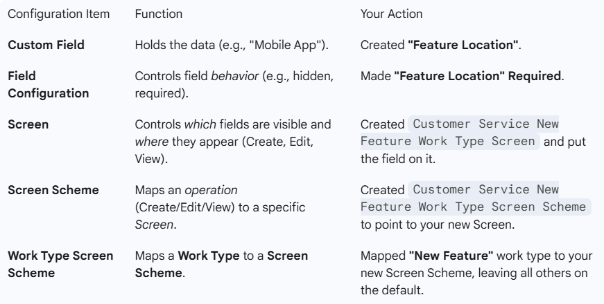

===================================================================================

1. **Using Screens and layout:**

You correctly highlighted the crucial difference:

* **Screens** primarily control **which fields** are displayed for the **Create, Edit, and View** operations. They are the fundamental, administrative layer.
* **Layouts** primarily control the **visual presentation** and **behavior** of fields on the **Work Item View Screen** (the main page for a ticket), adding features like:
  + The ability to **hide fields when empty** (the area below the dividing line).
  + A visual editor to rearrange fields and sections.

**Key Takeaways from Your Demonstration**

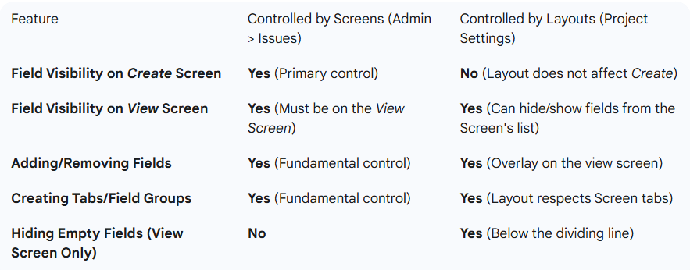

Your example with the **Components** field was spot-on:

* You proved that making a field visible in the **Layout** instantly makes it appear on the **Work Item View** even if it's empty.
* You correctly noted that the **Create Screen** remains entirely controlled by the **Screen configuration**, not the Layout setting for hiding empty fields.

This foundational understanding of how screens and layouts interact is essential for any Jira administrator, as it allows for precise control over the user experience, depending on whether a user is creating a new item or simply viewing an existing one.

You are now well-prepared to transition to the next critical topic: **Workflows**.

===================================================================================

1. **Understanding the concepts of workflows:**

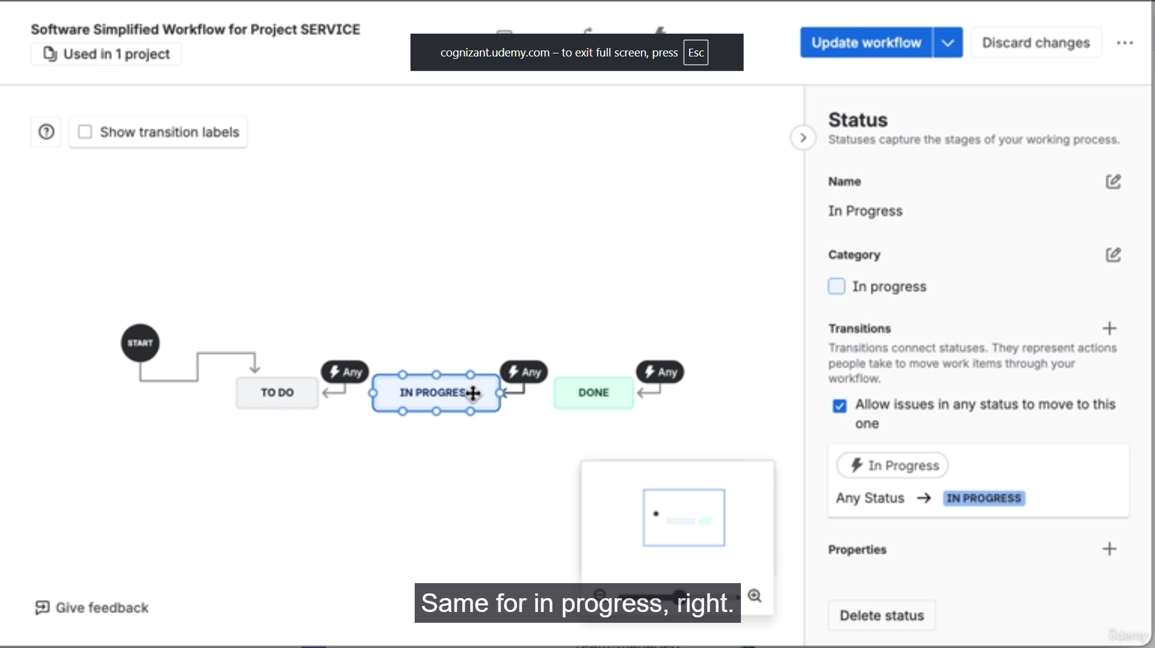

You successfully demonstrated the core concepts and administrative steps needed to customize how work moves through a project:

1. **Locating Workflows:** You showed how to access workflows both from the global Jira Administration area (under Work Items) and from the Project Settings.
2. **Using the Workflow Designer:** You correctly navigated the designer interface, which is the visual editor for creating and modifying the flow.
3. **Creating a Custom Status:** You added the **"Needs Approval"** status and correctly categorized it as an **"In Progress"** status category. This is a critical administrative step for ensuring the status has the correct meaning for reporting purposes.
4. **Understanding "Any Status" Transition:** You showed the default behavior where any status can transition to the new status.
5. **Setting Up a New Board (Kanban):** You quickly set up a Kanban board to test the workflow changes, adding the new **"Needs Approval"** column and mapping the new status to it. This highlights how the board configuration follows the workflow.
6. **Creating a Restricted Transition:** You demonstrated the power of workflows by:
   * Deleting the default "Any Status" transition.
   * Creating a specific **"In Progress $\rightarrow$ Needs Approval"** transition.
   * This enforced a rule: a feature must be worked on (In Progress) before it can be sent for approval.

**Summary of Workflow Components**

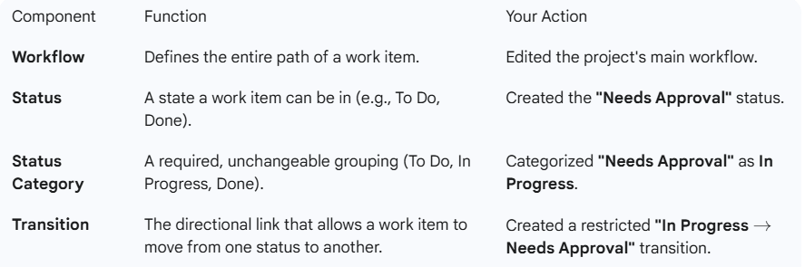

Your closing thought about **Rules** is an excellent segway. Transitions are the perfect place to apply automation rules (like permissions, conditions, validators, and post-functions) to make the workflow not just a visual guide, but an enforced business process.

The next video on **Automation** will build directly on the foundation you've established here with workflows and transitions. Well done!

===================================================================================

1. **Getting started with automation in Jira:**

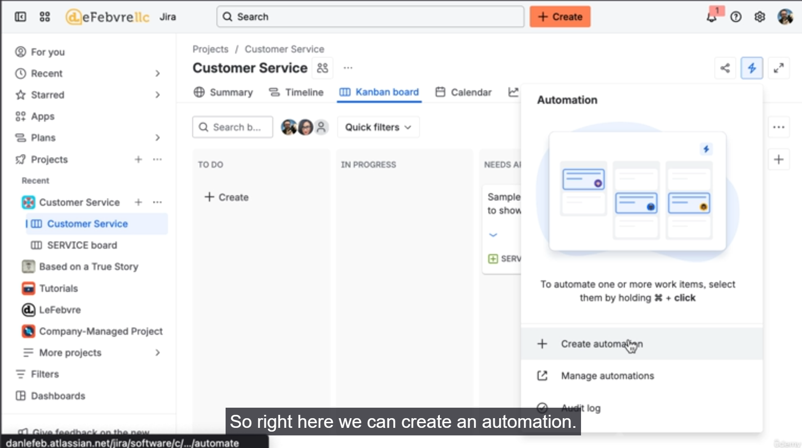

**1. Workflow Rules (Post Functions)**

You showed how to assign a work item immediately after a specific transition:

* **Location:** Added directly to the **transition** within the **Workflow Designer**.
* **Trigger:** The act of moving the work item from **"In Progress"** to **"Needs Approval"**.
* **Action:** Used the **"Assign an Issue"** action to set the assignee to a specific user (**Helen**).
* **Benefit:** Enforces a rigid, mandatory step in the process (getting the manager involved) without requiring any manual intervention.

**2. Project Automation Rules**

You created a flexible, date-driven rule to manage priority:

* **Trigger:** Used a **Field Value Changed** trigger, specifically checking for changes to the **Due Date**.
* **Condition:** Added a JQL query (due <= 7d AND status != Done) to ensure the rule only runs on active items due within one week. This is an advanced and powerful use of JQL within automation.
* **Action:** Used the **"Edit Issue"** action to set the **Priority** to **High**.
* **Demonstration:** You proved the rule works by setting a Due Date within the week, which automatically changed the priority from Low to High.

**3. Global vs. Project Scope**

You clarified the concept of scope and showed a powerful administrative trick:

* **Scope Difference:** You explained the difference between a rule that runs only within one project (like your initial Due Date rule) and a **Global** rule that runs across all projects in the Jira instance (like "Closing duplicate issues").
* **Import/Export:** You demonstrated the ability to **export** an automation rule to a JSON file and then **import** it back, changing its scope from a single project to **Global**. This is an invaluable administrative skill for reusing complex logic and migrating configuration.

This video effectively covered the core mechanics of Jira automation and provided great examples for speeding up processes and ensuring data governance. Now that you've covered the administrative backbone (work types, fields, screens, workflows, and automation), moving on to **Components** is a logical step to continue configuring project-level structure.

===================================================================================

1. **How to use Jira’s Component:**

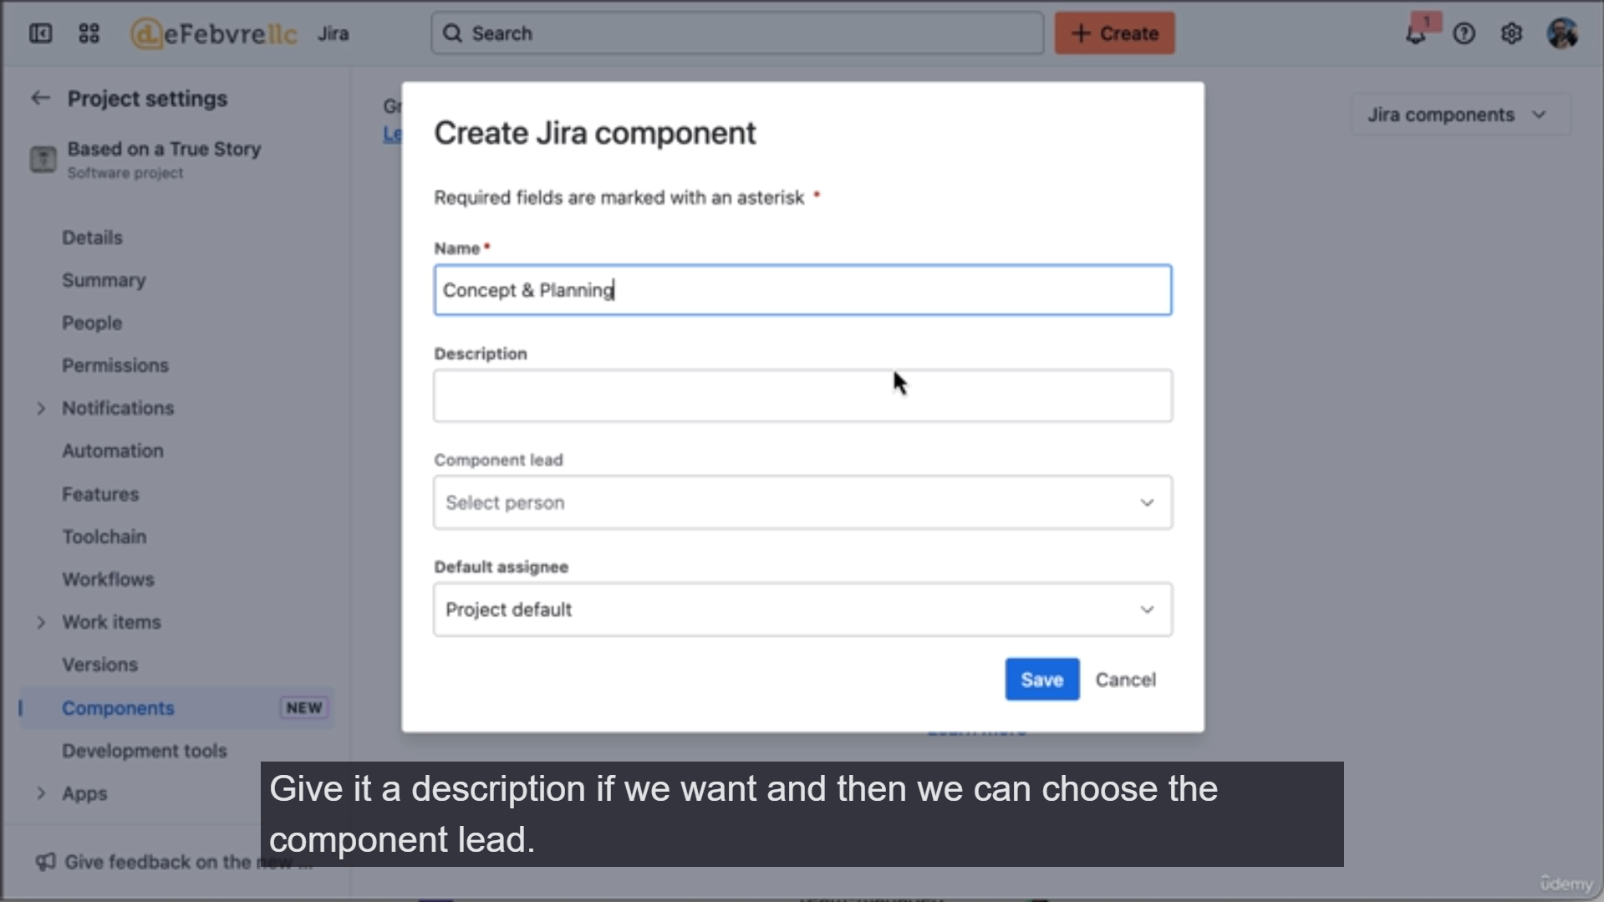

**1. Component Basics and Scope**

* **Definition:** You correctly defined components as a way to group work items into subareas (like "Concept and Planning" or "Guest Management") within a project.
* **Scope:** You clearly stated the essential limitation: **Jira Components are per-project** and do not span multiple projects.
* **The Component Lead:** You explained that setting a Component Lead (e.g., Dan or Helen) for a component is primarily for tracking ownership and is **not** an automatic assignment mechanism.

**2. Creating and Applying Components**

* You navigated to **Project Settings > Components** and created several components relevant to a podcast production project.
* You showed how the component count links directly to a Jira Query Language (JQL) filter, providing an instant view of all work items tagged with that component.
* You demonstrated that adding a component to a work item is simply filling a field on the issue view.

**3. Combining Components with Automation (The Power Move)**

This was the most valuable part of the demonstration, showing how to turn a passive administrative setting (Component Lead) into an active, process-enforcing rule:

* **The Problem:** Simply setting Noah as the Component Lead for "AV Production" doesn't assign work to him.
* **The Solution (Automation):**
  + **Trigger:** Set to run when the **Components** field value changes.
  + **Condition (JQL):** Used a conditional check to ensure the rule only runs if the component **changed to** "AV Production".
  + **Action:** Used the **"Edit Work Item"** action to assign the work to **Noah**.
* **Demonstration:** You proved that removing and then re-adding the "AV Production" component automatically updated the Assignee field to Noah.

By tying components together with JQL filtering and automation, you showcased how these administrative features work holistically to organize work and enforce business processes.

The logical next step in the work item lifecycle is to look at how work is completed, which makes the upcoming video on **Resolutions** a perfect continuation.

===================================================================================

1. **Using resolutions to track complete work:**

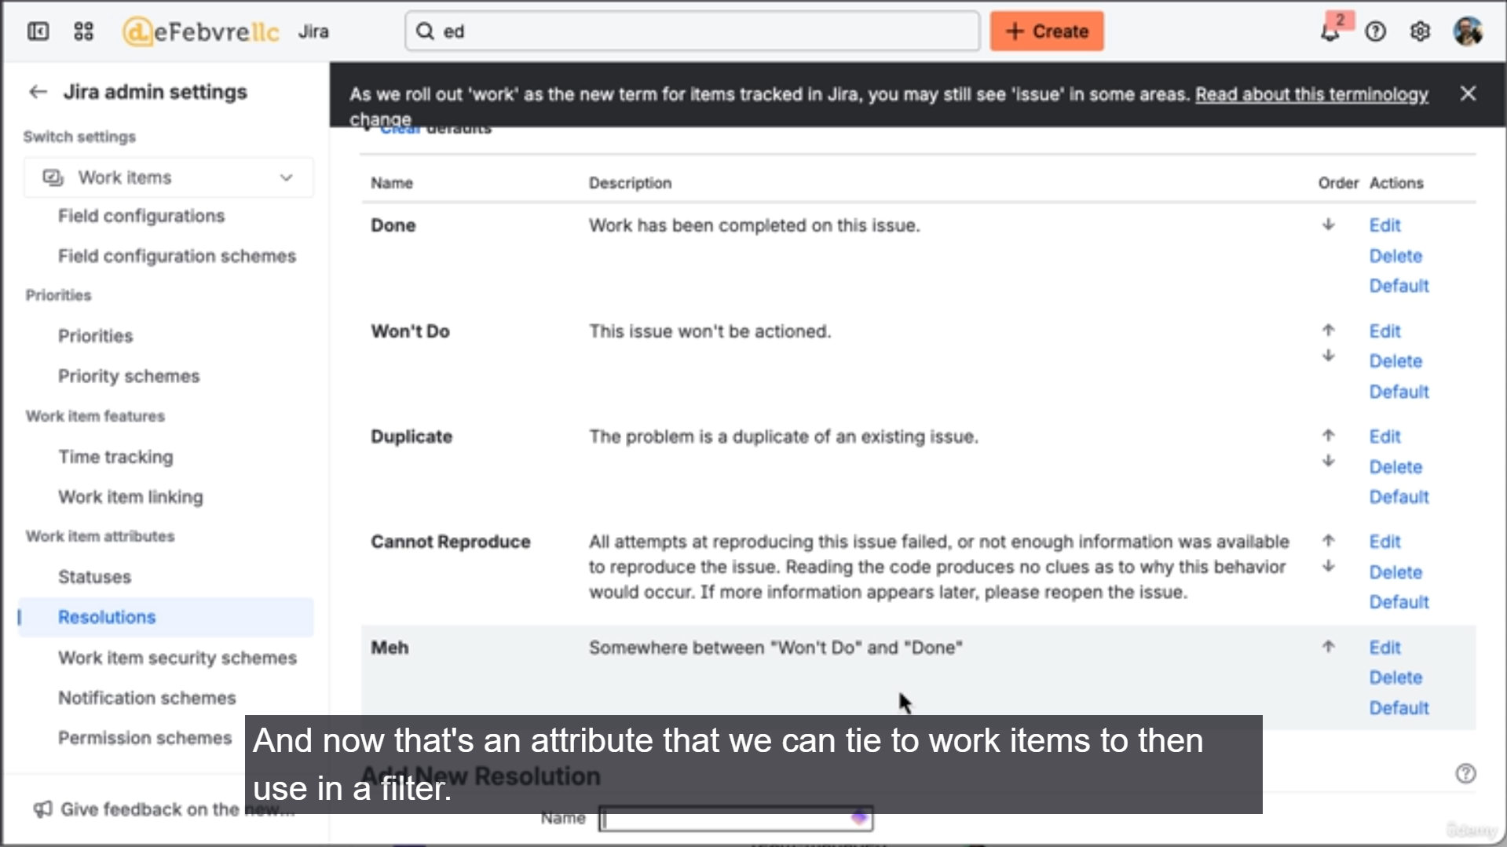

That was a clear and relatable example of why Resolutions are a crucial administrative concept in Jira! You effectively demonstrated that **Resolution** and **Status** are separate attributes, each serving a distinct purpose in the work lifecycle.

**Key Takeaways from the Resolution Demonstration:**

1. **Resolution vs. Status:** You highlighted the core difference:
   * **Status** tracks *where* the work item is in the process (e.g., "To Do," "In Progress," "Done").
   * **Resolution** tracks *why* or *how* the work was completed/closed (e.g., "Done," "Won't Do," "Later"). A work item is considered "truly done" or closed only when it has a Resolution value.
2. **Custom Resolution Creation:**
   * You navigated to **Jira Administration $\rightarrow$ Work Items $\rightarrow$ Resolutions**.
   * You created a custom resolution called **"Later"** (a great real-world example) to track work that is shelved but not officially "Done."
3. **Enforcing Resolution via Workflow:** This is the critical administrative link:
   * You accessed the **Workflow Designer**.
   * On the **Transition to the "Done" Status**, you added a **Screen** to the transition.
   * The purpose of this screen is to prompt the user to select a Resolution (like "Later" or "Done") *before* the work item enters the final status.
4. **Filtering for Resolutions:** You showed the practical payoff:
   * Work items dragged to "Done" now have a Resolution value (e.g., "Later").
   * This allows the former boss to use a simple filter (resolution = Later) to quickly pull up all the shelved ideas, separating them from work that was genuinely completed (resolution = Done).

By introducing a custom Resolution and associating it with the workflow transition via a screen, you've ensured data integrity and provided a valuable tool for future reporting and ideation.

Your transition to the next video on **Custom Statuses** is perfect, as Resolutions and Statuses are two sides of the same coin in Jira's configuration.

===================================================================================

1. **Creating custom statuses:**

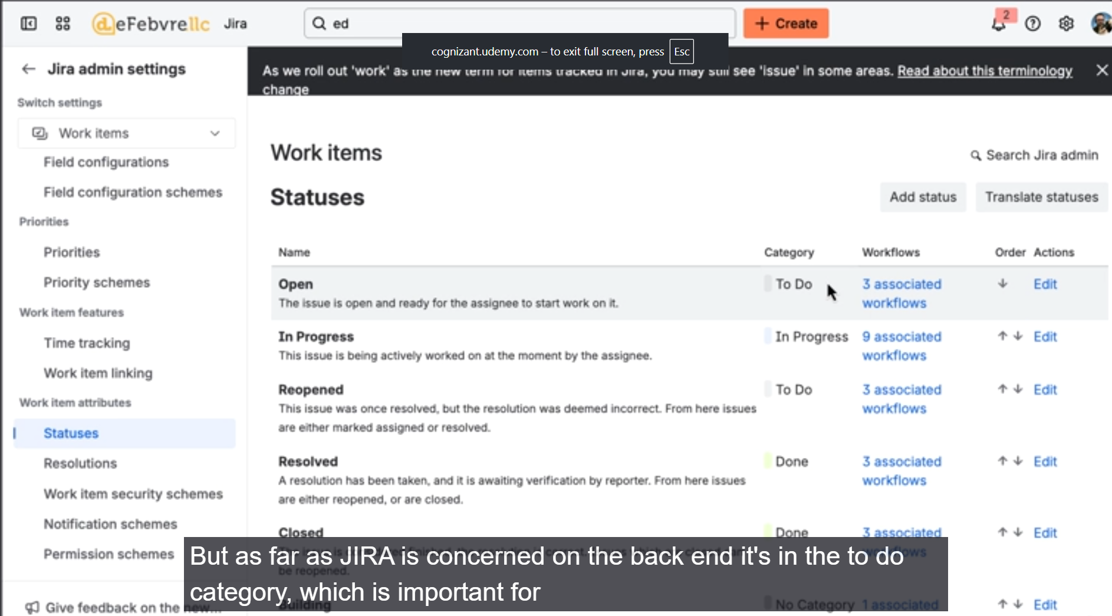

1. **Status as a Global Entity:** You correctly identified that statuses are created globally within Jira Administration and can be shared across all company-managed projects.
2. **The Three Immutable Status Categories:** You stressed the most important rule: while you can create unlimited custom **Statuses**, they **must** belong to one of the three unchangeable **Status Categories**:
   * **To Do (Grey)**
   * **In Progress (Blue)**
   * **Done (Green)**
3. **The Importance of Categories for Reporting:** You explained *why* categories matter, using the Control Chart as a perfect example—it tracks time in "Production" (i.e., time spent in the **In Progress** category), not just a specific status name.
4. **Creating a Custom Status:**
   * You created a new status called **"Rejected by QA"**.
   * You correctly assigned it to the **In Progress** category, acknowledging that most custom operational states fall under this group.
5. **Adding the Status to a Workflow:**
   * You demonstrated how to add an existing custom status to a project's workflow.
6. **Mapping the Status to the Board:**
   * You showed how to update the Kanban board by creating a new column (**"Rejected by QA"**) and mapping the new status to it, ensuring the visual board reflects the workflow change.
7. **Automation Potential:** You briefly highlighted the power of the new status by suggesting an automation rule (e.g., automatically assign to the Head of QA when an item moves to this status), tying back to the previous video's content.

This video effectively reinforces the layered administrative structure of Jira: the **Status** itself (what the user sees) is defined globally, while the **Workflow** (how it's used and where it transitions) and **Board** (how it's visualized) are defined at the project level.

The course is now logically moving from organizing individual work items to organizing groups of work items for planning, making the next video on **Versions** an ideal continuation.

===================================================================================

1. **Using release versions:**

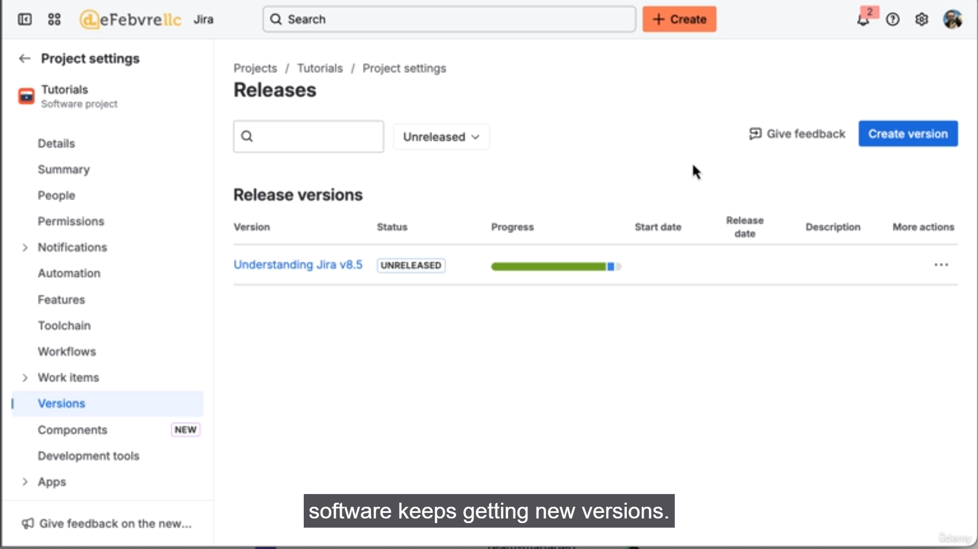

**Summary of Jira Versions (Releases)**

**1. Core Concept and Distinction**

* **What is a Version?** A version is a grouping mechanism used to track which work items (features, bugs, tasks, etc.) were shipped together as part of a specific product or application release (e.g., v1.0, v2.0).
* **Versions vs. Components:** While **Components** track sub-areas of work (like 'Payment Processor'), **Versions** track chronological groupings of work items for a specific delivery date.

**2. Administrative Scope and Terminology**

* **Project-Specific:** Just like Components, **Versions are limited to a single project**. You cannot use a version created in one project to tag a work item in another project.
* **Terminology Crossover:** You correctly pointed out that "Versions" and "Releases" are used interchangeably in the Jira interface, stemming from older terminology.

**3. Version Statuses and Metadata**

* **Status Tracking:** Versions have statuses similar to work items:
  + **Unreleased (In Progress):** Work is still ongoing for this version.
  + **Released (Done):** The version has been shipped.
  + **Archived:** Used to declutter the view by hiding older releases.
* **Key Metadata:** The version details page acts as a central hub, displaying:
  + **Linked Content:** Integrations for release notes (Confluence) or designs (Figma).
  + **Driver:** The point of contact for the release (similar to a work item's Reporter).
  + **Contributors:** Automatically tracked by Jira based on users who worked on the included items.
  + **Approvers:** A mechanism to track mandatory approvals before the version can be released (noting that only the actual approver can check their own box).
  + **Progress Report:** A quick, visual summary of work item status within the version.

**4. Integration with Agile Boards**

* **Kanban Board Release Tool:** You showed that Kanban boards offer a quick action to **create a release** from all items currently in the **Done** column. This speeds up the process of associating completed work with a new version.
* **Adding Work to a Version:** Work items can be manually added to a version using the **Fix Version** field on the work item itself, or in bulk from the version's detail page.

This video concludes a major section on organizing and structuring work, setting the stage for the final administrative overview.

===================================================================================

1. **Overview of Jira admin settings: System:**

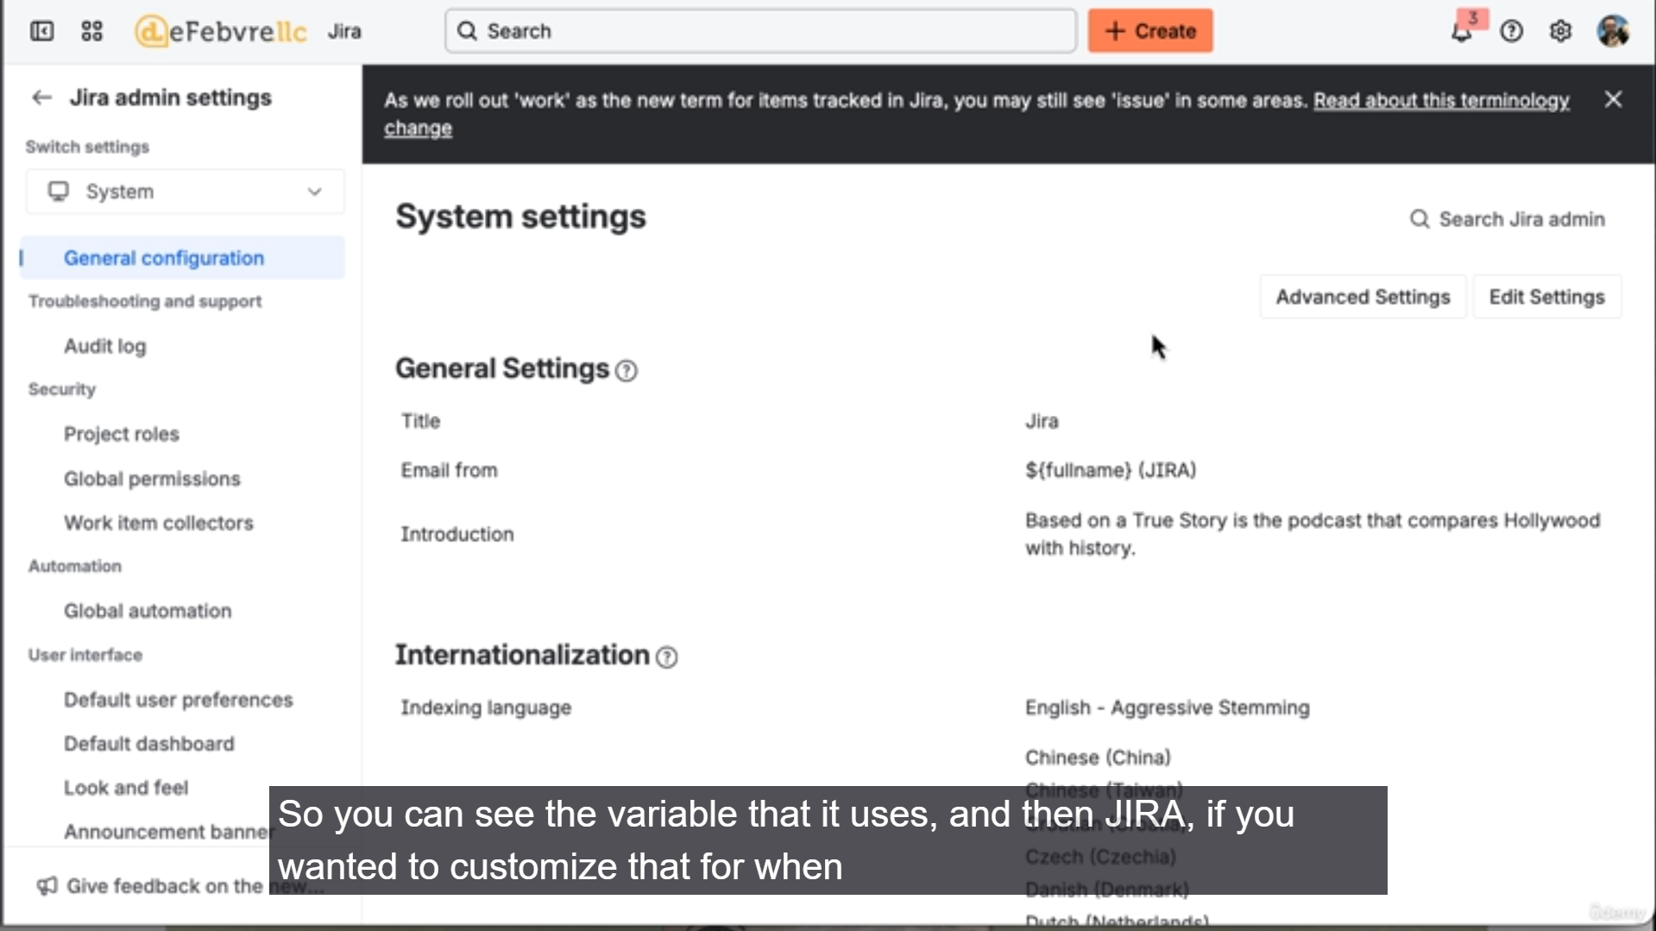

That was an exhaustive and helpful overview of the **Jira Global Administration** settings under the **System** menu!

You successfully guided the user through the less-frequently accessed but powerful administrative tools, highlighting what each one controls and its primary purpose.

**Summary of Jira Global System Administration Settings**

This section provided a high-level tour of the global settings found under the $\text{⚙} \rightarrow \text{System}$ menu, aiming to familiarize administrators with where to find key configurations.

**General Configuration & Customization**

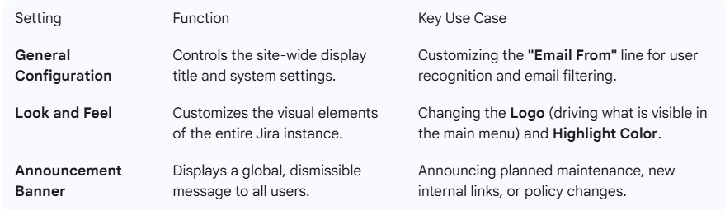

**Security and Permissions:**

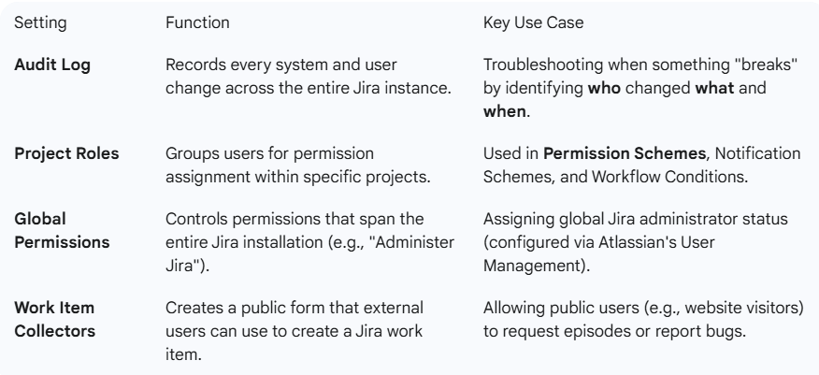

**Importing, Exporting, and Email:**

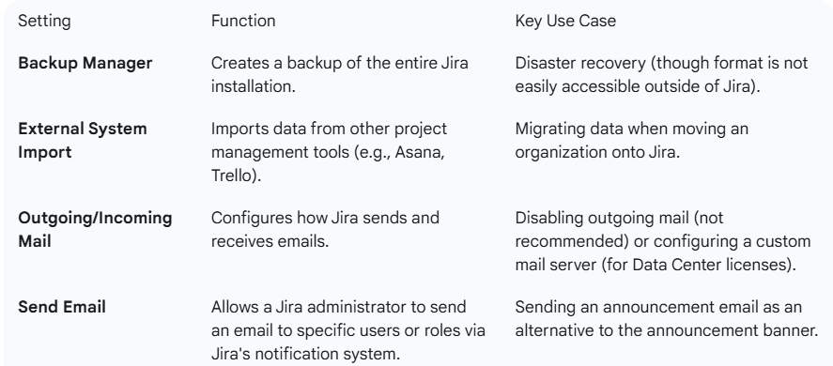

**Admin Helpers & Diagnostics:**

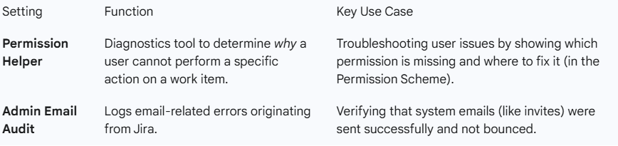

**Advanced System Settings:**

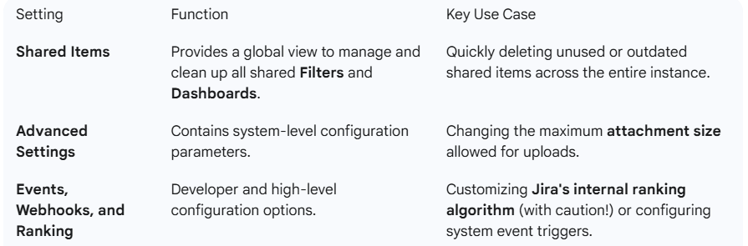

This overview successfully laid the groundwork for the next video, which will shift focus from global system settings to administrative settings related to **Products and Projects**.

===================================================================================

1. **Overview of Jira admin settings: Products and projects:**

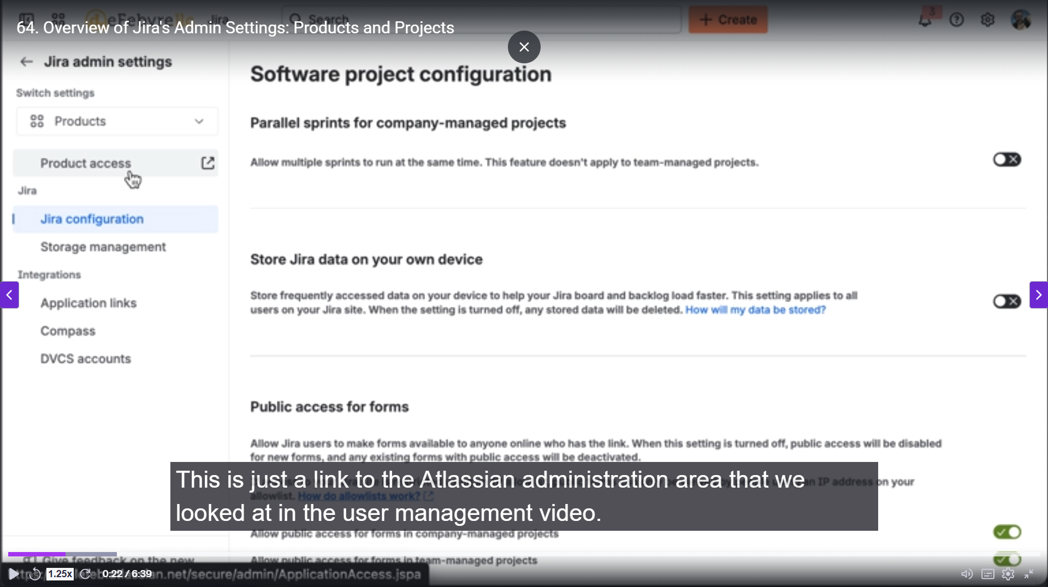

That was a focused and efficient overview of the **Product** and **Project** administrative settings in Jira, highlighting the settings that are most relevant to an administrator!

You effectively covered:

**1. Product Settings Overview**

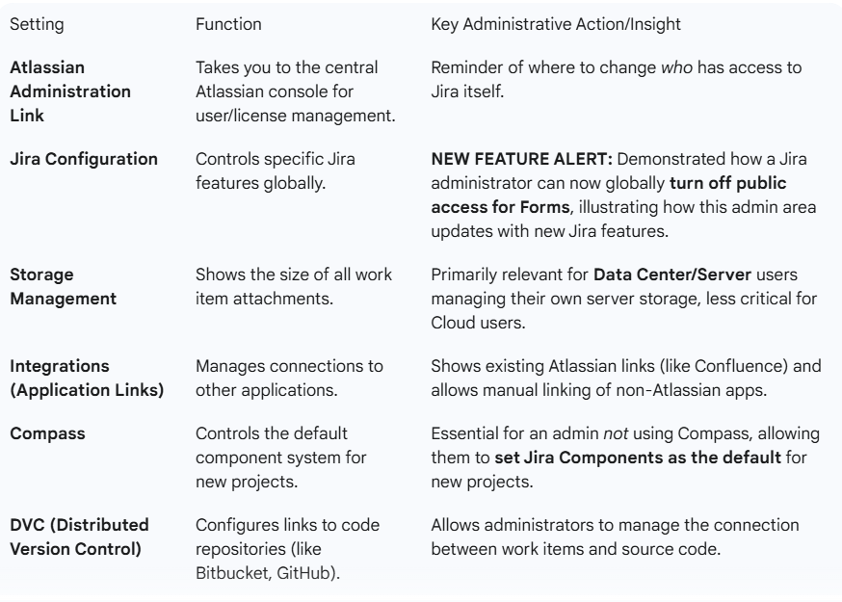

**2. Project Settings Overview**

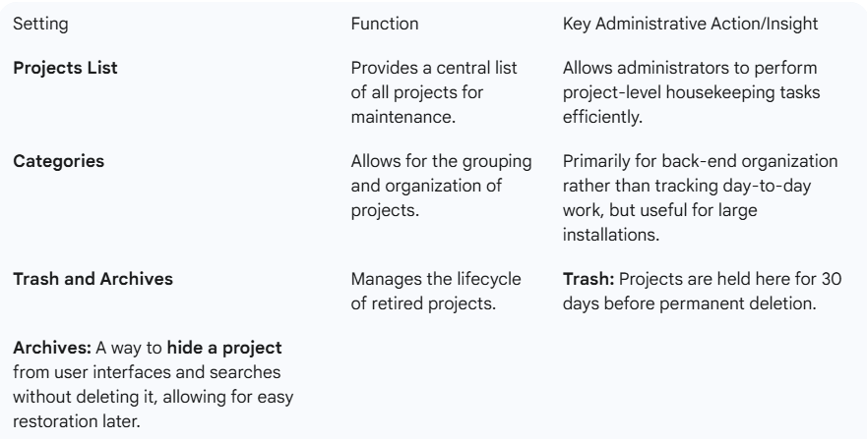

This video serves as a perfect bridge between the global **System** settings and the final high-level look at **Work Items and Apps**. You maintained a steady pace while clearly articulating which settings are crucial for a daily administrator versus those that are only occasionally used.

1. **overview of Jira admin settings: Work Items & Apps:**

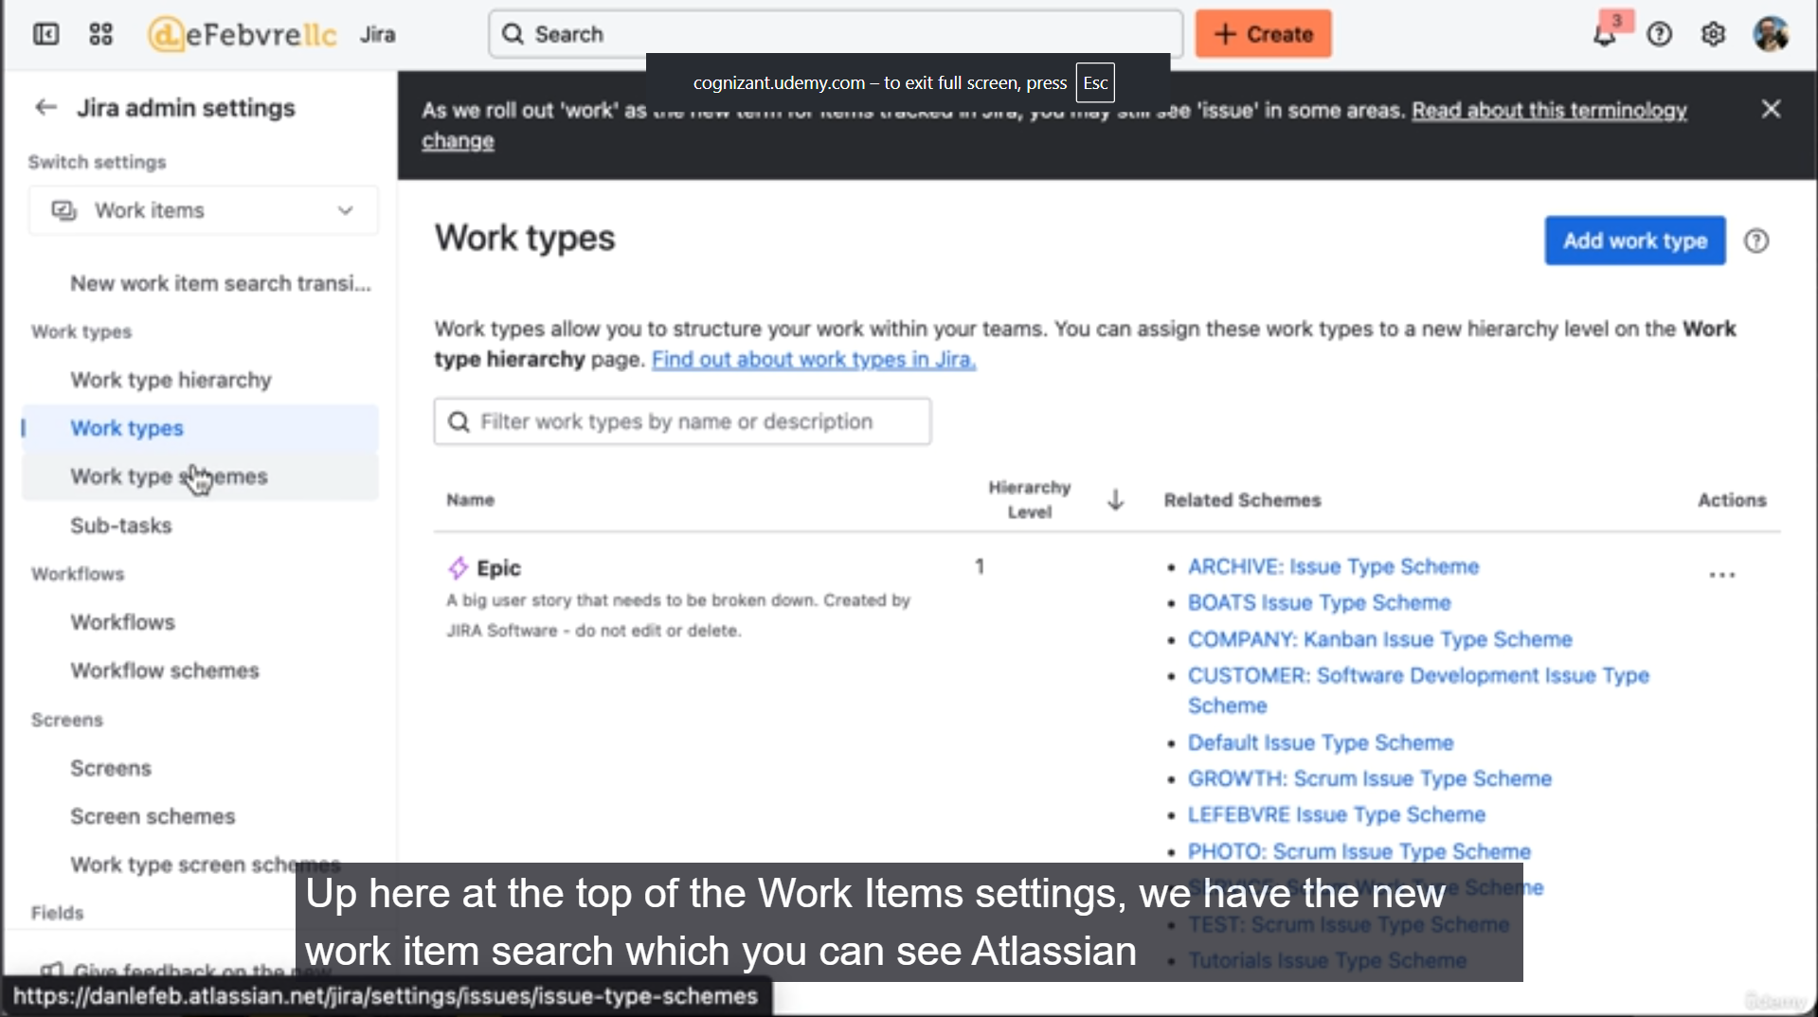

That was a thorough final overview of the Jira administrative settings, specifically focusing on the **Work Items** and **Apps** sections. You successfully highlighted the administrative centralization of features that were previously introduced on a project-level basis.

**Summary of Work Items and Apps Administration**

This section completes the high-level tour of the Jira Administration area ($\text{⚙} \rightarrow \text{Issues}$ and $\text{⚙} \rightarrow \text{Apps}$).

**1. Work Items (Issues) Administration**

This area centralizes the management of all configuration entities that define how work is structured, processed, and displayed across the entire Jira instance.

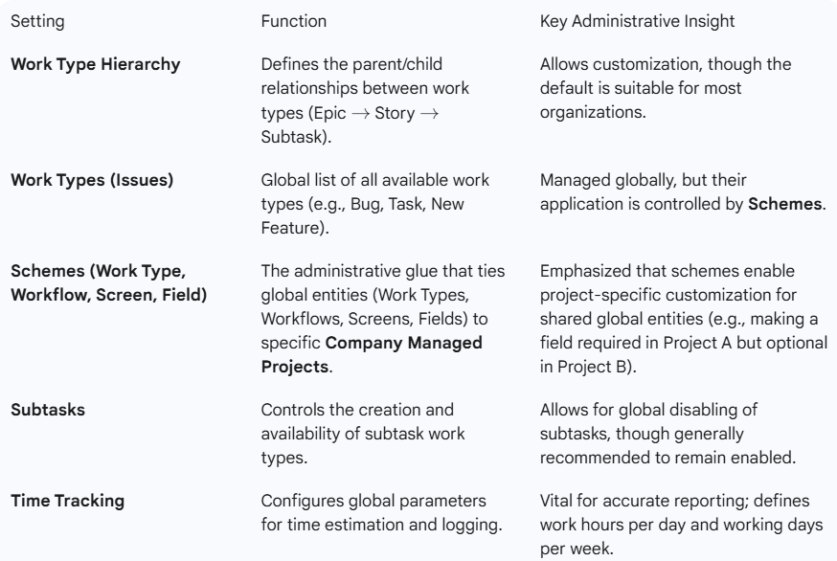

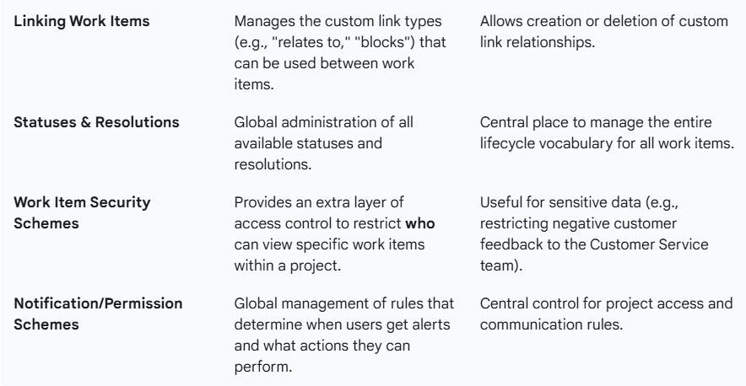

**2. Apps (Add-ons) Administration**

This section manages the integration of external software to extend Jira's functionality.

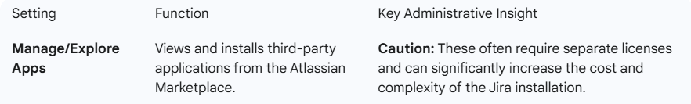

3. Atlassian Administration Links

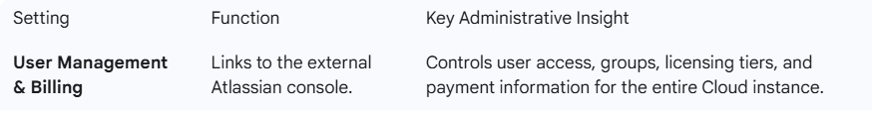

The overview effectively closed out the administrative section of the course, providing the user with the necessary context and location knowledge to confidently navigate Jira's global settings.

******************************************************************************************************************************************************************************************************************************************************************************************